BookRepository.java
package com.library.repository;
public class BookRepository {
public void displayBook() {
System.out.println("Book Repository is working");
}
}

BookService.java
package com.library.service;
import com.library.repository.BookRepository;
public class BookService {
private BookRepository repository;
public void setRepository(BookRepository repository) {
this.repository = repository;
}
public void showBook() {
System.out.println("BookService is working");
repository.displayBook();
}
}LibraryApplication.java
package com.library;
import org.springframework.context.ApplicationContext;
import org.springframework.context.support.ClassPathXmlApplicationContext;
import com.library.service.BookService;
public class LibraryApplication {
public static void main(String[] args) {
ApplicationContext context =
new ClassPathXmlApplicationContext("applicationContext.xml");
BookService service =
context.getBean("bookService", BookService.class);
service.showBook();
}
}
Main->resources->applicationContext.xml
<?xml version="1.0" encoding="UTF-8"?>
<beans xmlns="http://www.springframework.org/schema/beans"
xmlns:xsi="http://www.w3.org/2001/XMLSchema-instance"
xsi:schemaLocation="
http://www.springframework.org/schema/beans
https://www.springframework.org/schema/beans/spring-beans.xsd">
<bean id="bookRepository"
class="com.library.repository.BookRepository"/
<bean id="bookService"
class="com.library.service.BookService">
<property name="repository" ref="bookRepository"/>
</bean>
</beans>
Added dependency in pom.xml
<dependency>
<groupId>org.springframework</groupId>
<artifactId>spring-context</artifactId>
<version>5.3.39</version>
</dependency>
Output:
Spring loaded applicationContext.xml.
Spring created the BookRepository bean.
Spring created the BookService bean.
Spring injected the BookRepository into BookService using the setter method.
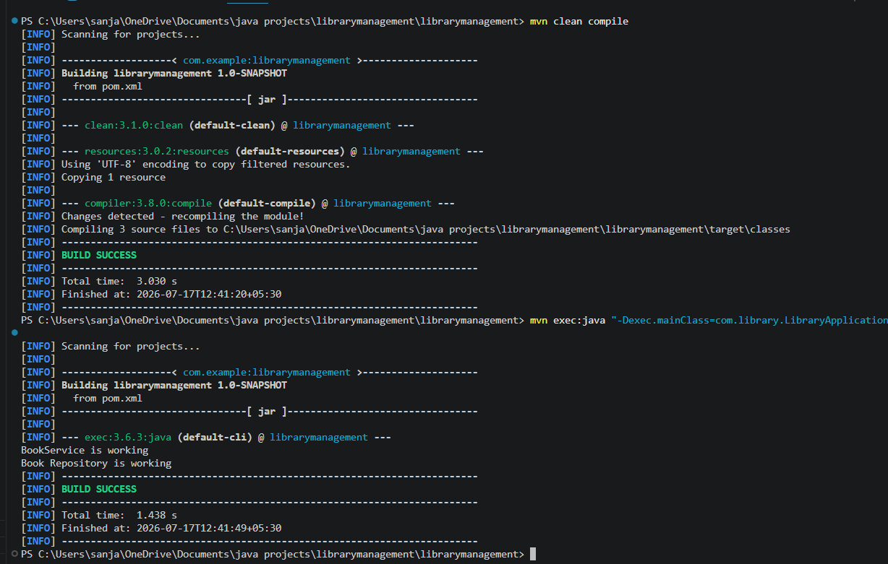
Images:
